Patrick Trinkle
CMSC691 IT Services
Summer 2008

Improving Quality of Service

Introduction
How does one measure and verify quality? Once an organization has decided they have reached a point in their processes where they want to audit everything, the organization registers for a standards audit. This will help determine where a company is and where it needs work. Being certified by an audit is also good for business. Companies can advertise this detail to earn more business and possibly expand their processes. It is cyclical in this nature that earning more business can help improve capabilities which allow for more business, which in turns earns more profit. There are quite a few various published standards related to quality management systems and information technology systems. Many of these have been published by the International Standards Organization. Organizations which provide services can use ISO 9001:2000, ISO 27001, ISO 20000, and eSCM-SP standards to determine capabilities for providing services. These diagnostics provide critical feedback in quality of service measurements. With global service providers, best practices are much more important, as their procedures are further reaching and can seriously impact the company. These standards audits require evidence of the processes in place. This evidence includes documentation as well as interviews with employees at different echelons. If an organization can reuse artifacts from one audit with another there is less disruption of the business. Therefore it is worth determining how feasible it is to reuse documents between quality standards. J. Hickey & J. Siegel performed a case study of document reuse between an internal ISO 9001:2000 audit and a self-appraised capability determination using eSCM-SP. The case study client is the Delivery Center 1 (DC1). DC1 is a global service delivery center which provides infrastructure services and solutions, and employees approximately 1000 personnel offshore. This organization supports 6 regions and several market sectors. The provided services include server administrator, storage, communications management, asset management, and help desk services.

Quality Standards
Quality standards are in place to ensure that a service provider employs the best possible processes and policies to control the quality of the provided service. The best possible processes are defined by various organizations, the sole purpose of which is to define such things. The best possible defined practice is an agreed upon level of quality for a particular process, such as knowledge management, innovation, relationship management, et cetera. A service provider will register to be audited by a professional or internal team to measure how the organizations policies address the quality of service standard being audited. Headquartered in Geneva, Switzerland, the International Standards Organization (ISO) is a leader in promulgating standards. ISO does not strictly create standards for quality management, but also various other standards used globally. The standards vary from how data is placed on a CD, to film shutter speeds, to the level of security in place to protect against corporate espionage. ISO 9001:2000 defines standards for a quality management system. ISO 27001 is a set of information security management system standards. ISO 20000 sets standards for IT Service Management. ESourcing Capability Model for Service Providers (eSCM-SP) was developed at Carnegie Mellon University’s IT Services Qualifications Center (ITSqc). ESCM-SP is a capability model for best practices.

Standards audits are performed either internally or by a team provided by the standards body or a certified auditor service provider. These auditors gain access to documents and employees to conduct analysis and interviews.
A company or organization will register for an audit, and by passing the audit they are certified by that standard—in this case ISO 9001:2000 certified. This strictly means that company or organization met the requirements of that standard. This certification does not guarantee quality of product or service—only that the business practices examined met the requirements. Therefore these standards certifications can be misleading. ISO 9001:2000 was originally ISO 9000. In 2000 it was combined with 9001, 9002, and 9003. Process management became a more notable part of this standard, bringing the entire structure of the standard itself into quality management. This standard is the most widely recognized for measuring outsourcing service quality. ISO 9001:2000 requirements are in five major clauses: quality management system; management responsibility; resource management; product realization; and measurement, analysis, and improvement. An organization must conform to all applicable clauses.
The eSCM-SP has three main purposes: providing clients with the ability to evaluate service provider capabilities; offer service providers a method of setting them apart; and to give service providers guidance regarding capability improvement. eSourcing refers to information technology as key to service delivery. The audit examines policies, guidelines, and job aids, interviews, artifacts. All of these are examined by a small team of trained evaluators. eSCM-SP has five capability levels from providing services to sustaining excellence. This standard offers several benefits. It is a standard specific to IT-enabled services and includes a capability model that has increasing capability levels—providing a road map. eSCM-SP provides full coverage of IT service management. There are 84 best practices and 78 of those practices were used in the case study. These are grouped into 10 capability areas. Six are ongoing throughout the service life style and addressed in the case study. This standard recognizes that outsourcing requires capabilities for both the service provider and the client. This is done via two models; one specifically for the clients.

The Case Study
DC1 began operation in January 2005 and provides Information Technology services. Information Technology services including offline storage, communications management, server administration, asset management, and help desk operations. The goal of this organization is to increase business significantly. These service quality assessments are being used to achieve this goal. DC1 engaged in both an internal and external ISO 9001:2000 audit and passed both. An internal eSCM-SP was conducted prior to a third-party evaluation. With the eSCM-SP audit focus was on the following capability areas: knowledge management, people management, performance management, relationship management, technology management, and threat management. Although ISO 9001:2000 does not address threat management—ISO 27001 can be substituted as necessary. Their case study analysis examines reuse of evidence; coverage between ISO 9001:2000 and eSCM-SP as defined by Carnegie Mellon University; and the process level examined in the external eSCM-SP evaluation. Figure 1 is an illustration of the coverage of eSCM-SP capability areas with ISO 9001:2000 created by Carnegie Mellon University. Used without their explicit permission.

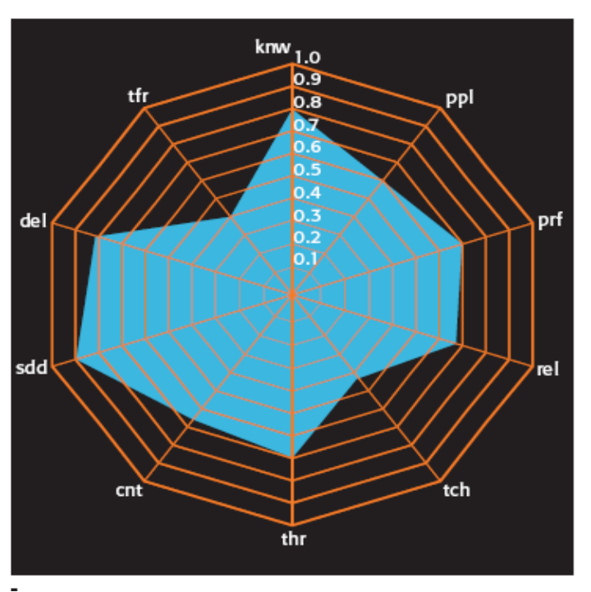
Figure 1, Correlation between ISO 9001:2000 & eSCM-SP
As determined by Carnegie Mellon University

Each of the practices has a short identifier for reference: knw for Knowledge Management; ppl for People Management; prf for Performance Management; rel for Relationship Management; tch for Technology Management; and thr for Threat Management. Averaging each of the 6 areas of document reuse individually results in the following: 76.15% for Knowledge Management; 61.20% for People Management; 77.90% for Performance Management; 60.94% for Relationship Management; 76.09% for Technology Management; 70.14% for Threat Management; 85.17% for Contracting; 71.30% for Service Design & Deployment; 81.46% for Service Delivery; 69.64% for Service Transfer. Reuse is the ability to satisfy evidentiary requirements of both the ISO and eSCM-SP.

Detailed Findings
The Knowledge management area relates to managing information and knowledge systems. There are eight practices in this capability area. The level of reuse in this area was the highest for DC1, 80%. “knw01 focuses on the establishment and maintenance of a knowledge-sharing policy.”¹ ISO 9001:2000 assigns management the responsibility of establishing a quality control policy as well as reviewing customer requirements. The goal of which is to encourage communication to aid learning and improving performance. Providing required information to personnel is covered by knw02. The primary process covering this was locally created. knw05 focuses on usage and analysis of knowledge gained through a lessons learned model. DC1 captured this information with a local process. ISO 9001:2000 completely covers this information gathering. The information is important to improve customer satisfaction, and product quality. eSCM-SP covers this as well as profitability and productivity. “knw06 specifies the reuse of work products within the organization across different customer accounts, such as the reuse of policies, technical designs, processes, or methods.”¹ DC1 reuses account processes and methods via global templates, and enabling tools. The level of reuse was higher than anticipated because the artifacts in the eSCM-SP evaluation used to demonstrate reuse of products between customers and this was the same evidence that demonstrated for ISO 9001:2000 the establishment and use of a quality management system. Therefore this reuse of artifacts is specific to DC1. “knw07 focuses on version and change control of work products.”¹ This practice contributes directly from ISO 9001:2000 to eSCM-SP. ISO 9001:2000 requires processes that control how the organization will control changes to relevant documents and records. This practice can be satisfied by using document and record control mechanism. 100% reuse between ISO 9001:2000 and eSCM-SP for this practice. Resource consumption is covered by knw08. A local process is used to manage resources in DC1. Typically global processes suffice to handle resource management. Due to the rapid growth there is a higher need for local processes to manage the changing resource requirements. A quality management system that predicts resource consumption will result in high reuse. This is because the reuse of documentation between the standards includes predictive measures.

The People management area contains 11 practices. These are all related to organizational personnel. Nine of the eleven processes are satisfied by global processes. The company focuses on innovation and IT capability therefore there is a heavy emphasis on employee retention and development. eSCM-SP includes ensuring the right skills are in place as well as that there are mechanisms in place to ensure employee retention, whereas ISO 9001:2000 does not require employee retention policies. “ppl01 focuses on establishing a policy to encourage innovation.”¹ Due to the nature of DC1’s business innovation is high prized. ISO 9001:2000 does not require programs focused on innovation. Although some reuse exists because there are innovation programs as part of a quality management system. “ppl02 focuses on obtaining the participation of personnel in decisions about their work commitments.”¹ Employee participation is only minimally addressed in ISO 9001:2000, but it is important for employee retention. A work environment that is properly arranged to allow for effective work is the focus of ppl03. This effective workplace relates to not only the physical work space but also dispute handling. ISO 9001:2000 does not address handling employee disputes. “ppl04 focuses on assigning roles and responsibilities to people based on their competencies while ppl05 focuses on the definition and communication of roles, responsibility, and authority of employees.”¹ ISO 9001:2000 requires the roles, responsibilities, and authority is documented and assigned within the organization. Determining needed staff is done via a global process. “ppl07 focuses on providing a cross-account training function that analyzes organizational needs, provides training solutions, tracks training, and improves training effectiveness.”¹ Training planning and provision is handled through a global function outside of the audit’s scope. Career development is handled through ppl10. DC1 uses global processes and tools to address ppl10. ISO 9001:2000 addresses skill development and training to meet quality requirements, but not to address long-term career development and organizational goals.

The Performance management area requires setting objectives, measuring performance, and complying with customer requirements. What is notable here is that of eleven practices, only one practice was satisfied by a global process. This is due to special circumstances related to DC1. A local process for handling performance enables maintenance of quality while the organization grows rapidly. “Eight of the practices had the majority of their activities satisfied by a highly structured performance review process instituted by the local management.”¹ ISO 9001:2000 coverage was high as well as reuse. Reuse was high because performance is managed through the quality management system. prf05 requires reviewing organizational performance. This practice is primarily satisfied by ISO 9001:2000 compliant processes. Reuse was 57%, although it was fully covered by ISO 9001:2000. Also of note, the eSCM evaluators used evidence beyond what was in the ISO 9001:2000 audit.
The Relationship management practices focusing on managing interactions with clients, and partners. There are 8 practices, and the reuse in this capability area was the lowest. The eSCM-SP focuses more on the formal relationship management; whereas the ISO 9001:2000 focuses on ensuring services must meet requirements. The global organization places emphasis on relationship management which helps satisfy the requirements. “rel01 focuses on managing interactions with clients.”¹ The practice requires a defined customer contact channel with defined roles and responsibilities and a communication plan. There are steady-state relationship management procedures used in eSCM-SP that are not in ISO 9001:2000, letting reuse by 50%.
The Technology management area ensures adequate technology infrastructure is capable of meeting service delivery requirements. The low findings in this area are due to the differing requirements. eSCM addresses a larger scope of the infrastructure than ISO 9001:2000. eSCM “includes the technology used to deliver outsourcing services.”¹ tch03 regards the management of technology changes. ISO 9001:2000 reviewed on the tool and did not specify the maintenance of a documented change management process. tch06 requires proactively introducing technology. There was 100% reuse of evidence due to the role that management review and quality management system play.
The Threat management area is aimed at security topics such as: security, confidentiality, organizational and engagement risk, and disaster recovery. "thr01 focuses on having a policy in place for risk management.”¹ Due to the fast pace of the organization’s growth the risk management focuses on having properly trained staff to handle accounts. thr07, which focuses on disaster recovery, was left out of the detailed findings.

Discussion
Significant reuse was found between the two standards audits. “The high reuse appears to be related to the maturity and the design of the DC1 quality management system.”¹ Several eSCM-SP practices not covered by ISO 9001:2000 reused evidence. ISO 9001:2000 does not require innovation programs or programs for process improvement. However, if there is emphasis in the organization on performance as well as efficiency there will be higher evidence reuse between ISO 9001:2000 and eSCM-SP. eSCM-SP has higher sensitivity regarding innovation and proactive performance programs as a diagnostic quality tool for an Information Technology organization. This is because ISO 9001:2000 is generic for quality management systems.
It is also possible that the high reuse of evidence can be attributed to the majority of global processes implemented by DC1. Table 2 summarizes the reuse in the audits.

Table 2: Summary of Reuse¹
Reuse by Capability Area | Total Items | Reused | eSCM-SP only | % Reuse
knw | 22 | 17 | 5 | 77.3
ppl | 46 | 29 | 17 | 63.0
prf | 33 | 21 | 12 | 63.6
rel | 31 | 18 | 13 | 58.1
tch | 26 | 16 | 10 | 61.5
thr | 22 | 13 | 9 | 59.1
cnt | 20 | 15 | 5 | 75.0
sdd | 26 | 17 | 9 | 65.4
del | 33 | 24 | 9 | 72.7
tfr | 11 | 8 | 3 | 72.7
Reuse by Capability Level | Total Items | Reused | % Reuse
Capability Level 2 | 96 | 54 | 56.25
Capability Level 3 | 67 | 29 | 58.21
Capability Level 4 | 36 | 21 | 58.33

Quality management systems that are ISO 9001:2000 compliant must collect measures in each of the following three categories: customer satisfaction; process quality; and product quality. Product is interchangeable with service for ISO 9001:2000. “Recommended measures for IT-enabled service delivery organizations implementing eSCM-SP include the following kinds of measures: (1) cost/effort; (2) status/progress; (3) nonconformance; and (4) performance/satisfaction.”¹

Conclusion
Further efforts are required to examine co-certification between other quality registrations and certifications. Each individual audit can require many resources from an organization therefore it intuitively follows that if any of these efforts can be combined there will be less of a negative impact on an organizations functions. The work presented by J. Hickey & J. Siegel can easily be paralleled as a model for comparing other standards to find commonality and potential artifact reuse.

Cited References
- J. Hickey, J. Siegel, Improving service delivery through integrated quality initiatives: A case study,
IBM Systems Journal, Vol 47, No 1, (2008).
http://www.research.ibm.com/journal/sj/471/hickeaut.html

